# 

# E-PLACEMENT MANAGEMENT BASED ON

# NOTEPAD ++ OVER PHP

*Submitted in the partial fulfillment of the requirements*

*For the award of the degree in*

### BACHELOR OF SCIENCE

### In

**COMPUTER SCIENCE**

**By**

### YUVARAJ. M (203031101159)

**SHEIK MOHAMED DHAYAN. S (203031101126)**

**YOGANADHAN. M (203031101156)**

** UNIVERSITY WITH SPECIAL AUTONOMY STATUS**

**APRIL 2023**

**DECLARATION**

We, **Mr.YUVARAJ.M Reg No.( 203031101159), Mr.SHEIK MOHAMED DHAYAN.S Reg No. (203031101126),Mr .YOGANADHAN.M Reg No . (203031101156)** here by declare that the project Report entitled **“E-PLACEMENT MANAGEMENT BASED ON NOTEPAD ++ OVER PHP”** is done by us under the Guidance of **Ms.R.HEMAVATHI** is submitted in partial fulfillment of the requirements for the award of the award of the degree in BACHELOR OF SCIENCE in computer science.

**1.**

**2.**

**3.**

**SIGNATURE OF THE CANDIDATE(S)**

**DATE :**

**PLACE :**



### DEPARTMENT OF COMPUTER SCIENCE

### 

### BONAFIDE CERTIFICATE

This is to certify that this project report is the bonafide work of **Mr.YUVARAJ.M Reg No.( 203031101159),Mr SHEIK MOHAMED DHAYAN S Reg No. (203031101126)**, **Mr .YOGANADHAN M Reg No .(203031101156)** who carried out the project entitled under our supervision from JAN 2023 to APRIL 2023

**Internal Guide HOD**

CS Department CS Department

Dr.M.G.R.Educational Dr.M.G.R.Educational

and Research Institute and Research Institute

**Submitted for Viva Voce Examination held on**

**Internal Examiner External Examiner**

**(**Name in capital letters (Name in capital letters with signature) with signature)

#### **ACKNOWLEDGEMENT**

We would first like to thank our beloved Chancellor

**Thiru A.C.Shanmugam, B.A., B.L.** and President **Er. A.C.S. Arunkumar, B.Tech., M.B.A.,** also our secretary **Thiru. A. Ravikumar** for all the encouragement and support extended to us during the tenure of this project and also our years of studies in his wonderful University.

We express our heartfelt thanks to our Vice-Chancellor

**Prof. Dr. S. Geetha Lakshmi** in providing all the support of our Project.

We express our heartfelt thanks to our Head of the Department,

**Prof. Dr. A. R. Arunachalam** who has been actively involved and very influential from the

start till the completion of our project

Our sincere thanks to our Project Coordinator **Dr. S.ISMAIL KALILULAH** and Project guide **Ms.R.HEMAVATHI.** for their continuous guidance and encouragement throughout this work, which has made the project a success.

We would also like to thank all the teaching and non teaching staffs of Computer Science department, for their constant support and the encouragement given to us while we went about achieving our project goals

**TABLE OF CONTENTS**

**CHAPTER NO: CONTENTS: PAGE**

**ABSTRACT 1**

1. **INTRODUCTION 2**
2. **SYSTEM ANALYSIS 3**

2.1 objectives

2.2 Problem definition

2.3 Existing system

2.4 Drawback of Existing system

2.5 Proposed system

* 1. Advantages of Proposed system

1. **FEASIBILITY STUDY 5**

3.1 Technical feasibility

3.2 Economical feasibility

3.3 operational feasibility

1. **DESIGN 7**
   1. Architecture diagram
   2. Algorithm
2. **PROJECT MODEL 8**
3. **CODING 9**

6**.**1 partial code

6.2 screenshot

1. **CONCLUSION 33**

**8. REFERENCE 34**

# ABSTRACT

# CONTENT :

# The E- PLACEMENT is a web based application developed in windows platform for the

placement department of the college in order to provide the details of its students in a database for the companies to their process of recruitment provided with a proper login. The system contains all the information about the students. The system stores all the personal information of the students and their technical skills that are required in the Resume to be sent to a company. The system is an online application that can be accessed throughout the organization and outside as well with proper login provided. The system can used for college to manage the student information with regards to placement details .This project contains all the details of the students that can be viewed by all the users (read only), but can be modified only by the student with an authorized service. The students can update their own information only. Students can search for the material required for the selection process for placement papers. Events happening in the college and the achievements of the student’s i.e. selected students’ details can be viewed by all the users. So, our project provides a facility of maintaining the details of the students, and gets the requested list of candidates for the companies who would like to recruit the people based on a given query

# CHAPTER 1

# INTRODUCTION

E- PLACEMENT MANAGEMENT is a total management and informative system, which provides the up-to date information of all the students in a particular college. E- Placement helps the colleges to overcome the difficulty in keeping records of hundreds and thousands of students and searching for a student eligible for recruitment criteria from the whole thing. It helps in effective and timely utilization of the hardware and the software resources. The administrator will create the users and the users will use the accounts created by administrator. When the user enters into his respective page he can update his details, and the details are to be approved by the administrator. All the users have some common services like changing password, updating details, searching for details, checking the details, mailing to administrator, and reading the material uploaded by admin if the user is a student. Administrator has the services to add events and achievements and he can reply to the mails sent by users. He can upload materials, search for student details, and he has the right to approve the students. This package is developed in windows platform. The programming language used is PHP , MYSQL is used as backend database for the details to be stored. E- PLACEMENT is a total management and informative system, which provides the up-to date information of all the students in a particular college. E PLACEMENT helps the colleges to overcome the difficulty in keeping records of hundreds and thousands of students and searching for a student eligible for recruitment criteria from the whole thing. It helps in effective and timely utilization of the hardware and the software resources.

# 

# 

# CHAPTER 2

# SYSTEM ANALYSIS

**2.1 OBJECTIVE:**

The main objective while implementing the project E-placement management System was

minimize the work process and at the same time increase the speed of the work done

**2.2** **PROBLEM DEFINITION :**

Now a day’s campus placement are conducted in all colleges. Various software and other

sector companies are conducting campus selections for selecting merit candidates.

When campus selections are conducted the students should provide their curriculum vitae

to the concern officer for attending the campus interviews. This routine process is maintained

manually, like maintenance of their resumes in papers. This can be automated by designing

software

**2.3 EXISTING SYSTEM AND ITS DRAWBACKS :**

The earlier system is not computerized. All transactions in the system are done manually maintaining records. To make this laborious job simple the clients have to computerize system. The management

and all the departments that have been carrying out this job using manually makes the job more and

complicated and tedious most of the times. So, the best way is computerize computerization of the

current environment.For example, in the earlier system placement officer has to collect student details

for placements.Approving those student details takes lot of time. Placement officer and students have

to consult each other directly if any information is needed. If any new company come for placements, placement officer and his staff has to search the student details and they have to find the eligible

candidates for that particular company placement. Here searching for eligible candidates takes lots

of time. And some times some candidates’ details may be missed.

**2.4 DRAWBACKS OF EXISTING SYSTEM :**

* It takes so much time for a placement officer to collect students’ details and approving the details provided by them.
* Poor communication between students and placement officer, so here intimating about new placements is a hard task.
* Students may not know about company details. Here also poor communication provides a problem.
* Candidate may not get required information if concerned TPO is not at the desk

**2.5 PROPOSED SYSTEM AND ITS MERITS :**

The proposed system is fully computerized, which removes all the drawbacks of existing

system. Proposed system is an online application that can be accessed throughout the organization

and outside as well with proper login provided. Students logging should be able to upload their information in the form of a RESUME. And the administrator will create the users and the users will use the accounts created by administrator.When the user entered into his respective page he has to update his details. And the details are to be approved by the administrator All the users have some common services like changing password, updating details, searching for details, checking the details, mailing to administrator, and reading the material uploaded by admin if the user is a student. Administrator has to do the services like adding events, achievements and he can reply to the mails sent by users. He can upload materials, search for student details, and he

has the right to approve the students

* 1. **ADVANTAGES OF THE PROPOSED SYSTEM :**
* Placement officer can easily collect student’ details, and approve the details provided by them.
* As it is an online application, communication with placement officer is easy to students and recruiters, so here intimating about new placements very easy task
* Here recruiters can also search for the details provided by students on the basis of thei percentage.
* Placement officer can send required materials used for placements preparation to

students. With this option preparation for placements becomes easy

**CHAPTER 3**

**FEASIBILITY STUDY**

**FEASIBILITY STUDY:**

The purpose of the feasibility study is not to solve the problem, but to determine the

problem is worth solving. This helps to decide whether to proceed with the problem or not

It involves the analysis of the problem & collection of all relevant information relating

to the product such as items that would be input to the system, processing required to carried

those data, the output data required to be produced by the system as well the various constraints

on the behavior of the system.

The feasibility study concentrates on the following, such as Technical Feasibility,

Economic Feasibility, Operational Feasibility

**3.1 TECHNICAL FEASIBILITY:**

It is technically feasible to design the project as; the entire modules described in the

modules description can be created using Front-End interaction HTML,CSS and back end PHP

database MYSQ and local hosted using xampp control panel.

ADVANTAGES OF MYSQL :

**1**.MySQL is one of the most popular choices for organization or businesses regarding

software as a services .

**2**. MySQL is easy to use and flexible RDBMS.

**3**. MySQL also offer host based verification and password encryption

**4.** Enterprises migrate from current database application to MySQL they save great deal on total .

cost of ownership

5. MySQL guarantees 24/7 uptime.

**3.2 ECONOMICAL FEASIBILITY**

The economic feasibility study evaluate the cost software development against

the ultimat income or benefits get from the developed system. There must be scope for

profit after the success completion of the project

**3.3 OPERATIONAL FEASIBILITY**

Operational feasibility study tests the operational scope of the software to be

developed. The proposed software must have high operational feasibility.

The usability will be high.

# 

# 

# 

# CHAPTER 4

# DESIGN

* 1. **ARCHITECTURE DIAGRAM**

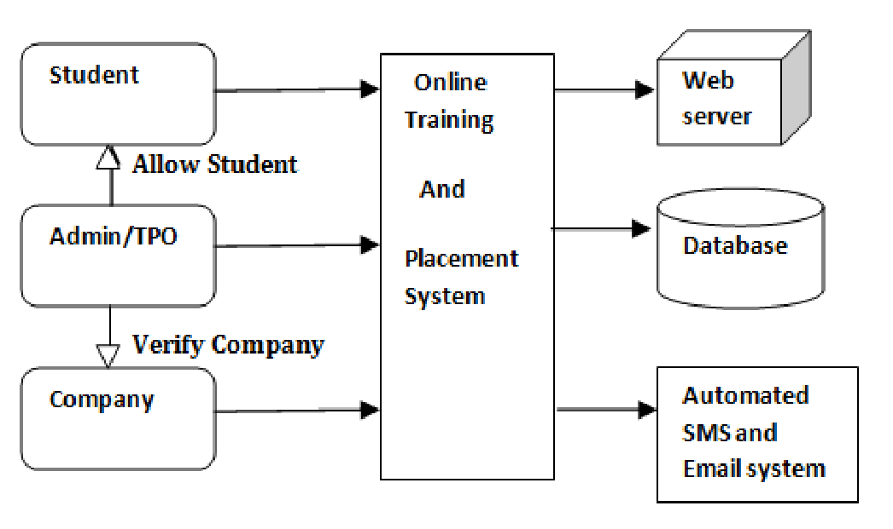

**5.2 ALGORITHM**

**STEP 1:** Start

**STEP 2:** Go to signup page and make signup first

**STEP 3:** And then redirected to login page and make login

**STEP 4:** Next redirected to home page

**STEP 5:** In this page can view various current job vacancy and click to apply button

**STEP 6:** Then redirected to student registration page fill the application and make submit

**STEP 7:** Finally successfully submitted job application

**STEP 8:** STOP

**CHAPTER 5**

**PROJECT MODEL**

**1.Student module consists of services like:**

o Signup details: This service provides the user to update their details.

o login details: This service provides the user to check his details are fetch and correct from signup.

o Apply job vacancy: This service provides the user to apply for various job vacancy

o Student registration: This service provides the user to update student details.

o About us: This service is used to know more about the website.

**2. Administrator module consists of services like***:*

o Update details: Allows administrator to update his (college) details

o Update statistics: Allows administrator to insert/update statistics like no. Of students selected etc

o Student details: Allows administrator to search for student information According to eligibility

criteria for recruitment proces

o Mailing: Allows administrator to reply for the mails sent by users

***2.* Recruiter module consists of services like:**

o College details: This service provides the user to check the college details.

o Student details: This service allows recruiter to search for student information

according to eligibility criteria for recruitment process.

o Mailing: This service provides the user to mail to administrator.

o confirmation mail : once the job process are completed the administrator send mail to user

whether the student is selected or not for the job position

# 

# 

# CHAPTER 6

# CODING

# PARTIAL CODE :

# 

# *Page1 : Sign Up.php*

# <?php

# session_start();

# if($_SERVER['REQUEST_METHOD'] == "POST")

# {

# include("connection.php");

# if(isset($_POST['submit']))

# {

# //somethign was posted

# $USERNAME = $_POST['USERNAME'];

# $USEREMAIL = $_POST['USERE-MAIL'];

# $USERPASSWORD = $_POST['USERPASSWORD'];

# $CONFIRMATIONPASSWORD = $_POST['CONFIRMATIONPASSWORD'];

# $duplicate = mysqli_query($con,"SELECT * FROM `signup` WHERE

# USEREMAIL='$USEREMAIL'");

# if(mysqli_num_rows($duplicate)>0)

# {echo"<script>alert('username or e-mail already exist');</script>";

# }

# else{

# if($USERPASSWORD == $CONFIRMATIONPASSWORD){

# $sql = "INSERT INTO signup (`USERID`, `USERNAME`, `USEREMAIL`,

# `USERPASSWORD`, `CONFIRMATIONPASSWOERD`) VALUES('0' ,

# '$USERNAME','$USEREMAIL','$USERPASSWORD',

# '$CONFIRMATIONPASSWORD')";

# $result = mysqli_query($con,$sql);

# header('location:login.php');

# echo"<script> alert('signup successful');</script>";

# }

# else

# {

# echo"<script> alert('PASSWORD DOES NOT MATCH');</script>";

# }

# }

# //echo "successful inserted data";

# }

# }

# ?>

# <!DOCTYPE html>

# <html>

# <head>

# <title>Signup Form</title>

# <style>

# body

# {

# margin: 0;

# padding: 0;

# font-family: 'Arial';

# background-image:url("pictuer.jpg");

# }

# .signup{

# width: 382px;

# overflow: hidden;

# margin: auto;

# margin: 20 0 0 450px;

# padding: 80px;

# background-color:rgba(0,0,0,0.2);

# border-radius: 15px ;

# }

# h1{

# text-align: center;

# color: #f6fdf8;

# padding: 20px;

# }

# label{

# color:#f6fdf8;

# font-size: 25px;

# }

# #Uname{

# width: 300px;

# height: 30px;

# border: none;

# border-radius: 3px;

# padding-left: 8px;

# padding-right:8px;

# }

# #Uemail{

# width: 300px;

# height: 30px;

# border: none;

# border-radius: 3px;

# padding-left: 8px;

# padding-right: 8px;

# }

# #Pass{

# width: 300px;

# height: 30px;

# border: none;

# border-radius: 3px;

# padding-left: 8px;

# padding-right: 8px;

# }

# #CPass{

# width: 300px;

# height: 30px;

# border: none;

# border-radius: 3px;

# padding-left: 8px;

# padding-right: 8px;

# }

# #sign{

# width: 300px;

# height: 30px;

# border: 100px 100px 100px 100p ;

# border-radius: 17px;

# padding-left: 7px;

# color: blue;

# }

# span{

# color: red;

# font-size: 17px;

# }

# a{

# width: 200px;

# height: 30px;

# border: 100px 100px 100px 100px;

# border-radius: 30px;

# padding-left: 5px;

# padding-right: 5px;

# color: #f6fdf8;

# }

# #login{

# width: 200px;

# height: 30px;

# border: 100px 100px 100px 100px;

# border-radius: 15px;

# padding-left: 10px;

# padding-right: 10px;

# background-color:rgb(0, 207, 0);

# }

# </style>

# </head>

# <body>

# <form METHOD="POST" enctype="multipart/form-data">

# <table>

# <h1>Signup Page</h1><br>

# <div class="signup">

# <label><b>USER NAME

# </b>

# </label>

# <input type="text" Name="USERNAME" id="Uname" placeholder="User name"

# required>

# <br><br>

# <label><b>USER EMAIL

# </b>

# </label>

# <div>

# <input type="email" Name="USERE-MAIL" id="Uemail" placeholder="User email"

# required>

# </div>

# <br><br>

# <label><b>USER PASSWORD

# </b>

# </label>

# <input type="Password-field" Name="USERPASSWORD" id="Pass"

# placeholder="Password" pattern="(?=.*\d)(?=.*[a-z])(?=.*[A-Z]).{8,}" required>

# <p style="color:red"><b>Password must contain the following:</b><br>

# <b> *Must have atleast one lowercase letter</b><br>

# <b> *Must have atleast one capital (uppercase)letter</b> <br>

# <b> *Must have atleast one number</b> <br>

# <b> *Must have atleast Minimum 8 characters</b> </p>

# <br>

# <label><b>CONFIRMATION PASSWORD

# </b>

# </label>

# <input type="Password-field" Name="CONFIRMATIONPASSWORD" id="CPass"

# placeholder="confirmation password" pattern="(?=.*\d)(?=.*[a-z])(?=.*[A-Z]).{8,}"

# required>

# <br><br>

# <input type="submit" Name="submit" id="sign" value="Signup Here">

# <br><br>

# <a href="login.php" id="login">back to login page</b></a>

# </table>

# </form>

# </div></body></html>

# *Page 2: login.php*

# <?php

# include("connection.php");

# if(isset($_POST['submit']))

# { include("connection.php");

# $USEREMAIL = $_POST['USERE-MAIL'];

# $USERPASSWORD = $_POST['USERPASSWORD'];

# $result = mysqli_query($con,"SELECT * FROM `signup` WHERE

# USEREMAIL='$USEREMAIL' AND USERPASSWORD='$USERPASSWORD'");

# $row = mysqli_fetch_assoc($result);

# if(mysqli_num_rows($result)>0)

# {

# if($USERPASSWORD == $row["USERPASSWORD"])

# {

# $_SESSION["login"]= true;

# $_SESSION["id"]= $row["id"];

# header("Location: home.php");

# }

# else{

# echo"<script> alert('user not Signup');</script>";

# }

# }

# }

# ?>

# <!DOCTYPE html>

# <html>

# <head>

# <title>Login Form</title>

# <style type="text/css">

# #(uemail,pass){

# width: 250px;

# height: 7em;

# }

# input, select, textarea {

# color: red;

# }

# #example {

# color: #0000ff;

# }

# </style>

# <style>

# body

# {

# margin: 0;

# padding: 0;

# font-family: 'Arial';

# background-image:url("e.jpg");

# }

# .login{

# width: 382px;

# overflow: hidden;

# margin: auto;

# margin: 20 0 0 450px;

# padding: 80px;

# background-color:rgba(0.2,0.2,0.2,0.3);

# border-radius: 15px ;

# }

# h1{

# text-align: center;

# color: #f6fdf8;

# padding: 20px;

# }

# label{

# color:#f6fdf8;

# font-size: 25px;

# }

# #Uemail{

# width: 300px;

# height: 30px;

# border: none;

# padding-left: 8px;

# padding-left: 10px;

# padding-right: 10px;

# }

# #Pass{

# width: 300px;

# height: 30px;

# border: none;

# border-radius: 3px;

# padding-left: 8px;

# padding-left: 10px;

# padding-right: 10px;

# }

# #log{

# width: 300px;

# height: 30px;

# border: 100px 100px 100px 100p ;

# border-radius: 17px;

# padding-left: 7px;

# color: blue;

# }

# span{

# color: red;

# font-size: 17px;

# }

# a{

# width: 200px;

# height: 30px;

# border: 100px 100px 100px 100px;

# border-radius: 30px;

# padding-left: 5px;

# padding-right: 5px;

# color: #f6fdf8;

# }

# #Fpass{

# width: 200px;

# height: 30px;

# border: 100px 100px 100px 100px;

# border-radius: 15px;

# padding-left: 10px;

# padding-right: 10px;

# background-color: rgb(255, 0, 0);

# }

# #newuser{

# width: 200px;

# height: 30px;

# border: 100px 100px 100px 100px;

# border-radius: 15px;

# padding-left: 10px;

# padding-right: 10px;

# background-color:rgb(0, 207, 0);

# }

# </style>

# </head>

# <body>

# <form METHOD="POST" ACTION="">

# <table>

# <h1>Login Page</h1><br>

# <div class="login">

# <label><b>USEREMAIL

# </b>

# </label>

# <input type="email" name="USERE-MAIL" id="Uemail" placeholder="User Email"

# required>

# <br><br>

# <label><b>USERPASSWORD

# </b>

# </label>

# <div>

# <input type="Password-field" name="USERPASSWORD" id="Pass"

# placeholder="Password" pattern="(?=.*\d)(?=.*[a-z])(?=.*[A-Z]).{8,}" required>

# </div>

# <br><br>

# <input type="submit" name="submit" id="log" value="Log In Here"><br><br>

# <a href="sign up.php" id="newuser">Sign up</b></a>

# </table>

# </form>

# </div>

# </body>

# </html>

***Page 3: logout***

<?php

include("connection.php");

$_SESSION =[];

SESSION_UNSET();

SESSION_DESTROY();

HEADER("LOCATION: login.php");

?>

***Page 4: About us***

<!DOCTYPE html>

<html>

<head>

<title>About Us</title>

</head>

<body style="background-color:rgb(235, 238, 166)">

<header>

<h1>About Us</h1>

</header>

<main>

<section>

<h2>Our Mission</h2>

<h1> <p> Welcome to our e-placement management platform, designed to help college students find their dream job and kickstart their career. We understand that finding the right job can be challenging, especially for students who are new to the job market. Our platform aims to make this process easier for you by providing a one-stop solution for all your job search needs.

At our e-placement management platform, we have a team of dedicated professionals who are passionate about helping students succeed. We work closely with employers to bring you the best job opportunities, and we provide you with the tools and resources you need to showcase your skills and stand out from the competition.

Our platform offers a range of features, including job search tools, resume building resources, interview preparation tips, and more. We are committed to providing you with a seamless user experience, and we are constantly updating our platform to meet your evolving needs.

Whether you're looking for an internship, part-time job, or full-time career, our e-placement management platform can help you achieve your goals. Join us today and take the first step towards building a successful and fulfilling career!</p></h1>

</section>

</body>

</html>

***Page 5: home.php***

<!DOCTYPE html>

<!-- Created By CodingNepal - www.codingnepalweb.com -->

<html lang="en" dir="ltr">

<head>

<meta charset="UTF-8">

<meta name="viewport" content="width=device-width, initial-scale=1.0">

<!------<title> Website Layout | CodingLab</title>------>

<link rel="stylesheet" href="style.css">

<link rel="stylesheet" href="https://cdnjs.cloudflare.com/ajax/libs/font-awesome/5.15.2/css/all.min.css"/>

</head>

<body style="background-color:rgb(234, 254, 255)">

<nav>

<div class="menu">

<div class="logo">

<a href="#"></a>

</div>

<ul>

<li><a href="About us.php">About</a></li>

<li><a href="logout.php">Logout</a></li>

</ul>

</div>

</nav>

<div class="img"></div>

<div class="center">

<div class="sub_title">WELCOME TO JOB PLACEMENT</div>

</div>

<div class="container">

<h2 class="title">Job Vacancy: Software Engineer</h2>

<p class="description"><h3>Job Description:</h3> A software engineer is responsible for designing, developing, testing, and maintaining software applications and systems. They use programming languages, software development tools,and techniques to create efficient and reliable software products that meet the needs of the end-users..<br>

<h3>Requirement:</h3>

*Bachelor's degree in computer science or a related field<br>

*Proficiency in programming languages such as Java, Python, or C++<br>

*Experience with software development methodologies such as Agile or Scrum<br>

*Familiarity with software development tools such as Git, Jira, or Jenkins<br>

*Strong analytical and problem-solving skills</p><br>

<a href="student registration form .php" class="apply-button">Apply Now</a>

</div>

<div class="container">

<h2 class="title">Job Vacancy: Data Scientist</h2>

<p class="description">

<h3>Job Description:</h3> Job Description: A data scientist is responsible for collecting, analyzing, and interpreting large and complex data sets to identify patterns, trends, and insights that can inform business decisions. They use statistical modeling, machine learning algorithms, and data visualization techniques to help organizations make data-driven decisions...<br>

<h3>Requirement:</h3>

*Master's or PhD in computer science, data science, or a related field<br>

*Proficiency in programming languages such as Python or R<br>

*Strong knowledge of statistics, machine learning, and data mining techniques<br>

*Experience with data analysis tools such as Pandas, NumPy, or SQL<br>

*communication and presentation skills</p><br>

<a href="student registration form .php" class="apply-button">Apply Now</a>

</div>

<div class="container">

<h2 class="title">Job Vacancy: Network Administrator</h2>

<p class="description"><h3>Job Description:</h3> Job Description: A network administrator is responsible for managing and maintaining computer networks, including hardware, software, and security systems. They ensure that the network is operating efficiently, troubleshoot any issues that arise, and implement security measures to protect the network from unauthorized access or attacks...<br>

<h3>Requirement:</h3>

*Bachelor's degree in computer science or a related field<br>

*Knowledge of network protocols and technologies such as TCP/IP, DNS, and VPNs<br>

*Experience with network administration tools such as Wireshark, Nagios, or SolarWinds<br>

*Familiarity with network security technologies such as firewalls and intrusion detection systems<br>

*Strong problem-solving and analytical skills</p><br>

<a href="student registration form .php" class="apply-button">Apply Now</a>

</div>

<div class="container">

<h2 class="title">Job Vacancy: Cybersecurity Analyst</h2>

<p class="description"><h3>Job Description:</h3> Job Description: A cybersecurity analyst is responsible for identifying and preventing cyber threats to an organization's computer systems and networks. They analyze security risks and vulnerabilities, develop security policies and procedures, and implement security measures to protect against cyber attacks...<br>

<h3>Requirement:</h3>

*Bachelor's degree in computer science, cybersecurity, or a related field><br>

*Strong knowledge of cybersecurity concepts and technologies such as cryptography, network security, and threat intelligence><br>

*Experience with security tools such as vulnerability scanners, penetration testing tools, and SIEMs><br>

*Familiarity with security frameworks such as NIST, ISO, or CIS><br>

*Strong communication and collaboration skills</p><br>

<a href="student registration form .php" class="apply-button">Apply Now</a>

</div>

</body>

</html>

***Page 6: Student registration .php***

<?php

session_start();

include("connection.php");

if(isset($_POST['submit']))

if($_SERVER['REQUEST_METHOD'] == "POST")

{

include("connection.php");

if(isset($_POST['submit']))

{

//somethign was posted

$ID = $_POST['ID'];

$FIRST_NAME = $_POST['FIRST_NAME'];

$LAST_NAME = $_POST['LAST_NAME'];

$REGISTRATION_NUMBER = $_POST['REGISTRATION_NUMBER'];

$BIRTHDAY_DAY = $_POST['BIRTHDAY_DAY'];

$BIRTHDAY_MONTH = $_POST['BIRTHDAY_MONTH'];

$BIRTHDAY_YEAR = $_POST['BIRTHDAY_YEAR'];

$E_MAIL = $_POST['E_MAIL'];

$MOBILE_NUMBER = $_POST['MOBILE_NUMBER'];

$GENDER = $_POST['GENDER'];

$ADDRESS = $_POST['ADDRESS'];

$CITY = $_POST['CITY'];

$PINCODE = $_POST['PINCODE'];

$STATE = $_POST['STATE'];

$COUNTRY = $_POST['COUNTRY'];

$SKILLSET = $_POST['SKILLSET'];

$CLASSX_BOARD = $_POST['CLASSX_BOARD'];

$CLASSX_PERCENTAGE = $_POST['CLASSX_PERCENTAGE'];

$CLASSX_YROFPASSING = $_POST['CLASSX_YROFPASSING'];

$CLASSXII_BOARD = $_POST['CLASSXII_BOARD'];

$CLASSXII_PERCENTAGE = $_POST['CLASSXII_PERCENTAGE'];

$CLASSXII_YROFPASSING = $_POST['CLASSXII_YROFPASSING'];

$GRADUATION_BOARD = $_POST['GRADUATION_BOARD'];

$GRADUATION_PERCENTAGE = $_POST['GRADUATION_PERCENTAGE'];

$GRADUATION_YROFPASSING = $_POST['GRADUATION_YROFPASSING'];

$MASTERS_BOARD = $_POST['MASTERS_BOARD'];

$MASTERS_PERCENTAGE = $_POST['MASTERS_PERCENTAGE'];

$MASTERS_YROFPASSING = $_POST['MASTERS_YROFPASSING'];

$COURSE = $_POST['COURSE'];

$DEPARTMENT = $_POST['DEPARTMENT'];

$JOBROLE = $_POST['JOBROLE'];

$UPLOAD_RESUME = $_POST['UPLOAD_RESUME'];

$sql = "INSERT INTO `student registration form`(`ID`, `FIRST_NAME`, `LAST_NAME`, `REGISTRATION_NUMBER`, `BIRTHDAY_DAY`, `BIRTHDAY_MONTH`, `BIRTHDAY_YEAR`, `E_MAIL`, `MOBILE_NUMBER`, `GENDER`, `ADDRESS`, `CITY`, `PINCODE`, `STATE`, `COUNTRY`, `SKILLSET`, `CLASSX_BOARD`, `CLASSX_PERCENTAGE`, `CLASSX_YROFPASSING`, `CLASSXII_BOARD`, `CLASSXII_PERCENTAGE`, `CLASSXII_YROFPASSING`, `GRADUATION_BOARD`, `GRADUATION_PERCENTAGE`, `GRADUATION_YROFPASSING`, `MASTERS_BOARD`, `MASTERS_PERCENTAGE`, `MASTERS_YROFPASSING`, `COURSE`, `DEPARTMENT`, `JOBROLE`, `UPLOAD_RESUME`) VALUES ('0','$FIRST_NAME','$LAST_NAME','$REGISTRATION_NUMBER','$BIRTHDAY_DAY','$BIRTHDAY_MONTH','$BIRTHDAY_YEAR','$E_MAIL','$MOBILE_NUMBER','$GENDER','$ADDRESS','$CITY','$PINCODE','$STATE','$COUNTRY','$SKILLSET','$CLASSX_BOARD','$CLASSX_PERCENTAGE','$CLASSX_YROFPASSING','$CLASSXII_BOARD','$CLASSXII_PERCENTAGE','$CLASSXII_YROFPASSING','$GRADUATION_BOARD','$GRADUATION_PERCENTAGE','$GRADUATION_YROFPASSING','$MASTERS_BOARD','$MASTERS_PERCENTAGE','$MASTERS_YROFPASSING','$COURSE','$DEPARTMENT','$JOBROLE','$UPLOAD_RESUME')";

$result = mysqli_query($con,$sql);

header('location:final page.php');

echo"<script> alert('updataed successful');</script>";

}

else

{

echo"<script> alert('something wrong information');</script>";

}

}//echo "successful inserted data";

?>

<!DOCTYPE html>

<html lang="en" >

<head>

<meta charset="UTF-8">

<title>Student Registration Form</title>

<style>

table{

background-color:rgb(210, 230, 255;

}

.container {

margin-top: 50px;

background-color: #fff;

border-radius: 15px;

padding: 0px 0px 0px 0px;

box-shadow: 0px 0px 10px rgba(0,0,0,0.2);

max-width: 0px;

margin: 0 auto;}

.button {

display: inline-block;

padding: 10px 20px;

background-color: #4CAF50;

color: #fff;

text-decoration: none;

border-radius: 5px;

font-size: 16px;

transition: background-color 0.3s ease;

}

.button:hover {

background-color: #3e8e41;

}

</style>

</head>

<body style="BACKGROUND-COLOR:rgb(210, 230, 255)">

<h3 styLe="font-size:25px" style="PADDING:10PX" align="center"> STUDENT REGISTRATION FORM </h3>

<form Method="POST" style="font-size:20px">

<table align="center" cellpadding = "10">

<!----- First Name ---------------------------------------------------------->

<tr>

<td>FIRST NAME </td>

<td><input type="text" name="FIRST_NAME" maxlength="30" REQUIRED>

(max 30 characters a-z and A-Z)

</td>

</tr>

<!----- Last Name ---------------------------------------------------------->

<tr>

<td>LAST NAME</b></td>

<td><input type="text" name="LAST_NAME" maxlength="30" REQUIRED>

(max 30 characters a-z and A-Z)

</td>

</tr>

<!----- registration number ---------------------------------------------------------->

<tr>

<td>REGISTRATION NUMBER</b></td>

<td><input type="NUMBER" name="REGISTRATION_NUMBER" maxlength="30" REQUIRED>

(max 30 characters a-z and A-Z)

</td>

</tr>

<!----- Date Of Birth -------------------------------------------------------->

<tr>

<td>DATE OF BIRTH </td>

<td>

<select name="BIRTHDAY_DAY" id="Birthday_Day" REQUIRED>

<input type =”integer” id="Birthday_Month" name="BIRTHDAY_MONTH">

<select name="BIRTHDAY_YEAR" id="Birthday_Year" REQUIRED>

<!----- Email Id ---------------------------------------------------------->

<tr>

<td>EMAIL ID</td>

<td><input type="email" name="E_MAIL" maxlength="100" REQUIRED></td>

</tr>

<!----- Mobile Number ---------------------------------------------------------->

<tr>

<td>MOBILE NUMBER </td>

<td>

<input type="number" name="MOBILE_NUMBER" maxlength="10" REQUIRED>

(10 digit number)

</td>

</tr>

<!----- Gender ----------------------------------------------------------->

<tr>

<td>GENDER </td>

<td>

Male <input type="radio" name="GENDER" value="Male" >

Female <input type="radio" name="GENDER" value="Female">

</td>

</tr>

<!----- Address ---------------------------------------------------------->

<tr>

<td>ADDRESS <br /><br /><br /></td>

<td><textarea name="ADDRESS" rows="4" cols="30" REQUIRED></textarea></td>

</tr>

<!----- City ---------------------------------------------------------->

<tr>

<td>CITY </td>

<td><input type="text" name="CITY" maxlength="30" REQUIRED>

(max 30 characters a-z and A-Z)

</td>

</tr>

<!----- Pin Code ---------------------------------------------------------->

<tr>

<td>PIN CODE </td>

<td><input type="number" name="PINCODE" maxlength="6" REQUIRED>

(6 digit number)

</td>

</tr>

<!----- State ---------------------------------------------------------->

<tr>

<td>STATE </td>

<td><input type="text" name="STATE" maxlength="30" REQUIRED>

(max 30 characters a-z and A-Z)

</td>

</tr>

<!----- Country ---------------------------------------------------------->

<tr>

<td>COUNTRY </td>

<td><input type="text" name="COUNTRY" value="India" readonly="readonly" REQUIRED></td>

</tr>

<!----- Hobbies ---------------------------------------------------------->

<tr>

<td>SKILLSET </td>

<td><input type="text" name="SKILLSET" value="" maxlength="30" REQUIRED></td>

</tr>

<!----- Qualification---------------------------------------------------------->

<tr>

<td>QUALIFICATION <br /><br /><br /><br /><br /><br /><br /></td>

<td>

<table>

<tr>

<td align="center"><b>Sl.No.</b></td>

<td align="center"><b>Examination</b></td>

<td align="center"><b>Board</b></td>

<td align="center"><b>Percentage</b></td>

<td align="center"><b>Year of Passing</b></td>

</tr>

<tr>

<td>1</td>

<td>Class X</td>

<td><input type="text" name="CLASSX_BOARD" maxlength="30" REQUIRED></td>

<td><input type="number" name="CLASSX_PERCENTAGE" maxlength="30" REQUIRED></td>

<td><input type="number" name="CLASSX_YROFPASSING" maxlength="30" REQUIRED></td>

</tr>

<tr>

<td>2</td>

<td>Class XII</td>

<td><input type="text" name="CLASSXII_BOARD" maxlength="30" REQUIRED></td>

<td><input type="nummber" name="CLASSXII_PERCENTAGE" maxlength="30" REQUIRED></td>

<td><input type="number" name="CLASSXII_YROFPASSING" maxlength="30" REQUIRED></td>

</tr>

<tr>

<td>3</td>

<td>Graduation</td>

<td><input type="text" name="GRADUATION_BOARD" maxlength="30" REQUIRED></td>

<td><input type="number" name="GRADUATION_PERCENTAGE" maxlength="30" REQUIRED></td>

<td><input type="number" name="GRADUATION_YROFPASSING" maxlength="30" REQUIRED></td>

</tr>

<tr>

<td>4</td>

<td>Masters</td>

<td><input type="text" name="MASTERS_BOARD" maxlength="30"></td>

<td><input type="number" name="MASTERS_PERCENTAGE" maxlength="30"></td>

<td><input type="number" name="MASTERS_YROFPASSING" maxlength="30"></td>

</tr>

<tr>

<td></td>

<td></td>

<td align="center">(10 char max)</td>

<td align="center">(upto 2 decimal)</td>

</tr>

</table>

<!----- Course ---------------------------------------------------------->

<tr>

<td> COURSES COMPLETED</td>

<td>B.E<input type="Radio" name="COURSE" value="B.E"></td>

<td>BCA<input type="Radio" name="COURSE" value="BCA"></td>

<td>B.Com<input type="Radio" name="COURSE" value="B.Com"></td>

<td>B.Sc<input type="Radio" name="COURSE" value="B.Sc"></td>

<td>B.A<input type="Radio" name="COURSE" value="B.A"></td>

</tr>

<!----- department ---------------------------------------------------------->

<tr>

<td>DEPARTMENT </td>

<td><input type="text" name="DEPARTMENT" maxlength="30" REQUIRED>

</td>

</tr>

<!----- jobrole ---------------------------------------------------------->

<tr>

<td>JOBROLE </td>

<td><input type="text" name="JOBROLE" maxlength="30" REQUIRED>

</td>

</tr>

<!----- upload resume ---------------------------------------------------------->

<tr>

<td>UPLOAD RESUME </td>

<td><input type="file" name="UPLOAD_RESUME" REQUIRED>

</td>

</tr>

<!----- Submit and Reset ------------------------------------------------->

<tr>

<td align="right" >

<input type="submit" name="submit" id="log" value="SUBMIT"></td></tr></table> </form></body></html>

***Page 7: Exist page***

<!DOCTYPE html>

<html>

<head>

<title>Application Submitted</title>

</head>

<body>

<div class="container">

<h1> THANK YOU </h1>

<p>Your application has been submitted successfully.</p>

<a href="home.php" class="button">Back to Home</a>

</div>

</body>

</html>

**6.2 SCREENSHOT :**

***Page 1: Sign Up :***

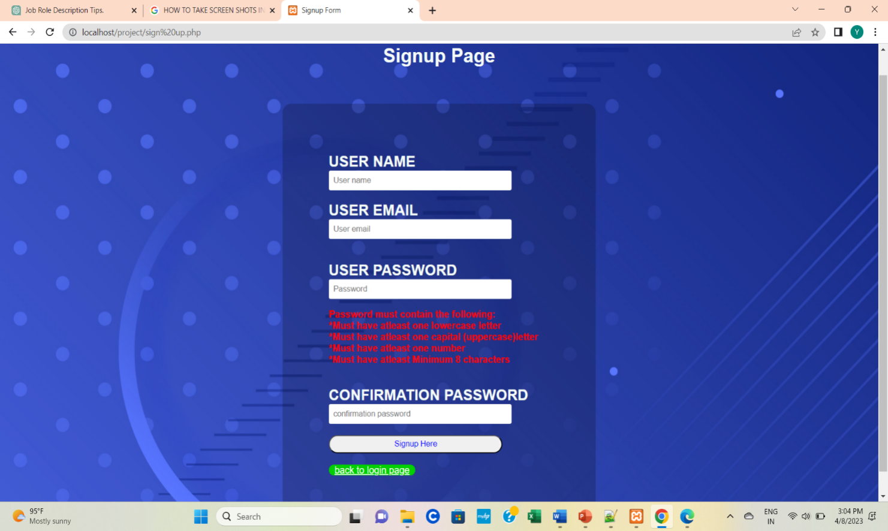

***Page 2: Login :***

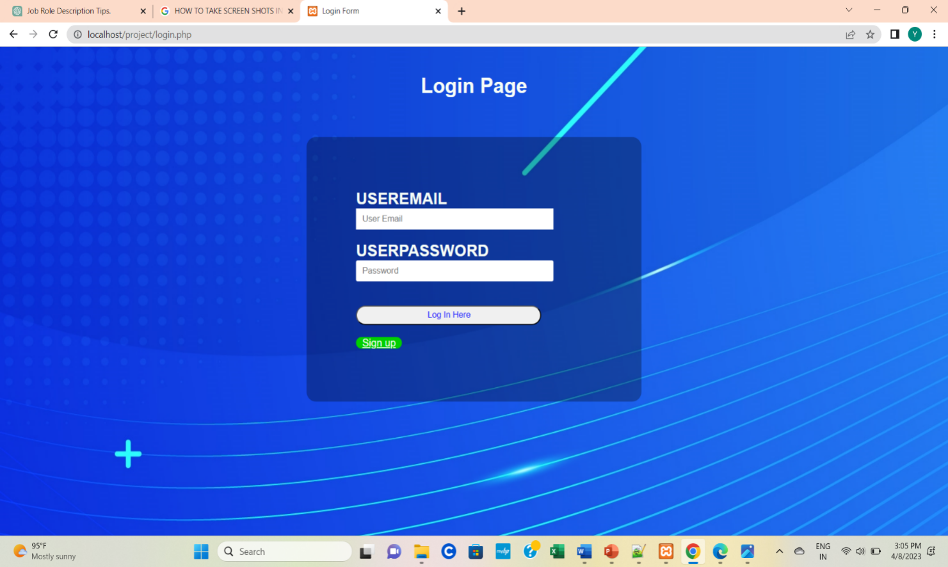

***Page 3: Home :***

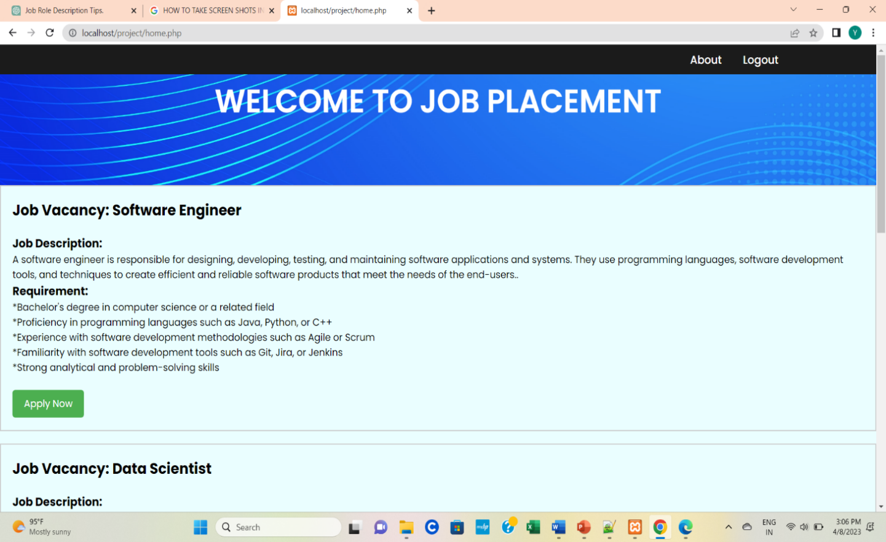

***Page 4: About Us :***

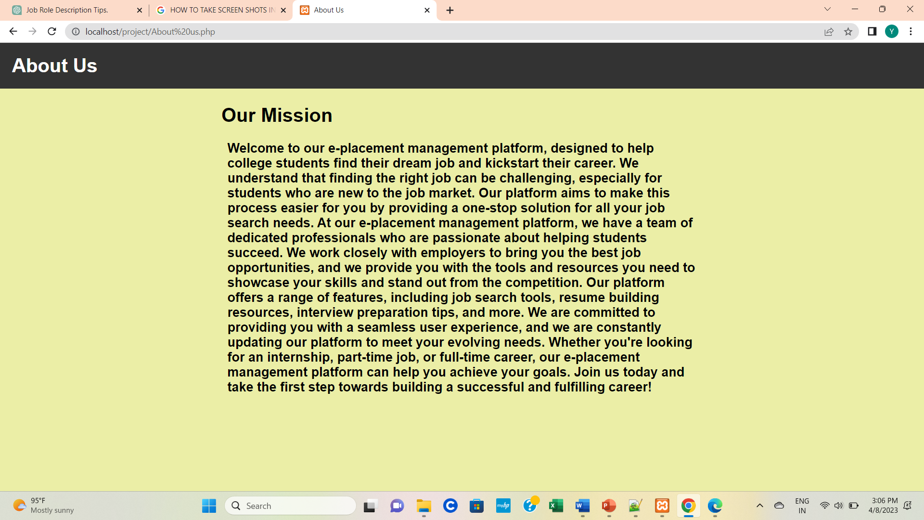

***Page 5: Student Registration :***

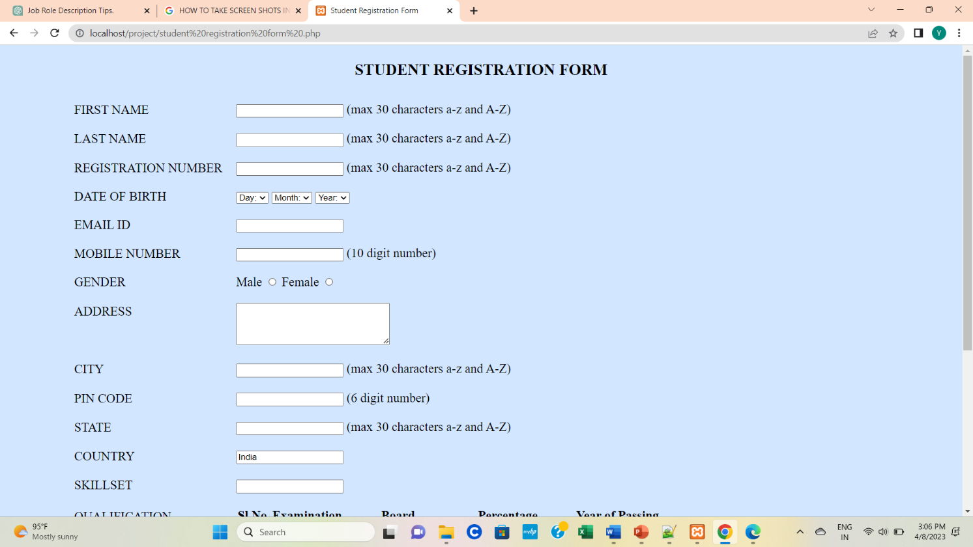

***Page 6: Exist :***

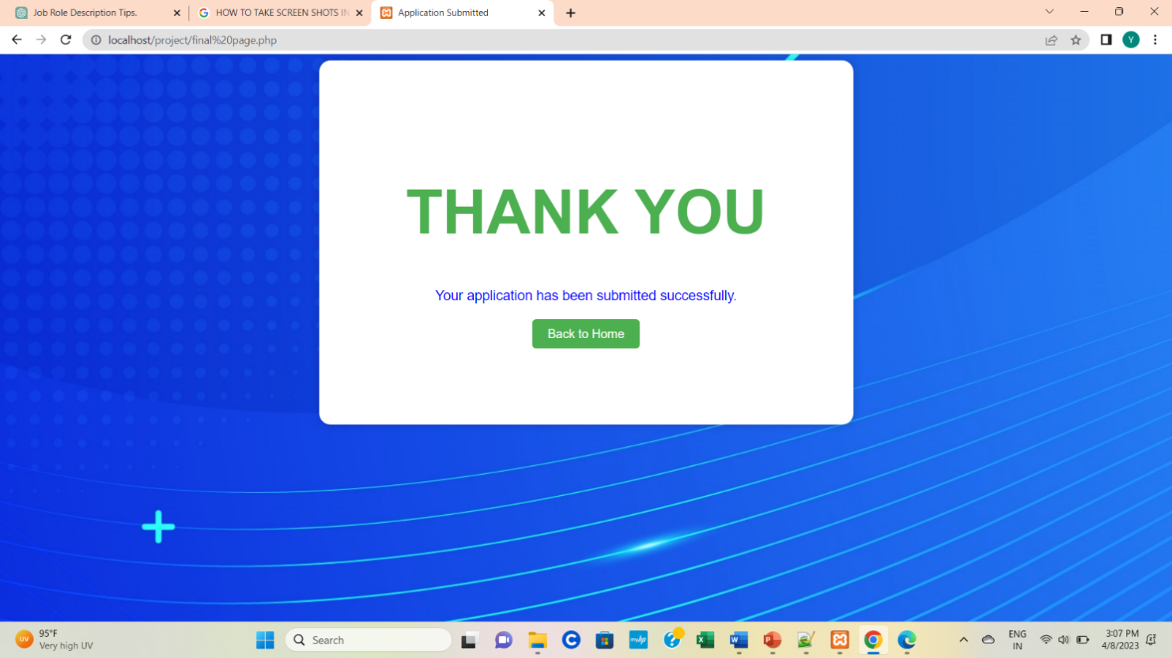

***Page 7: sign up database :***

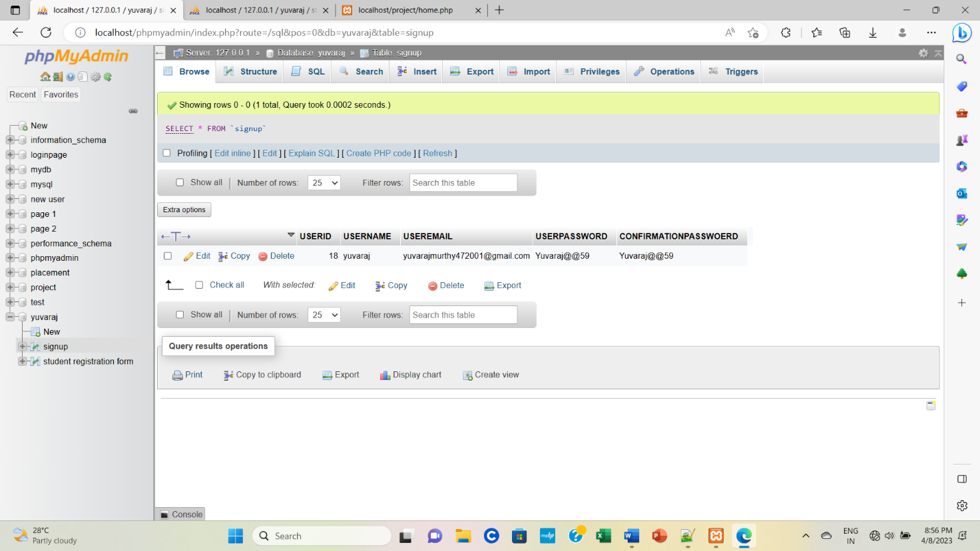

***Page 7: students registration form database :***

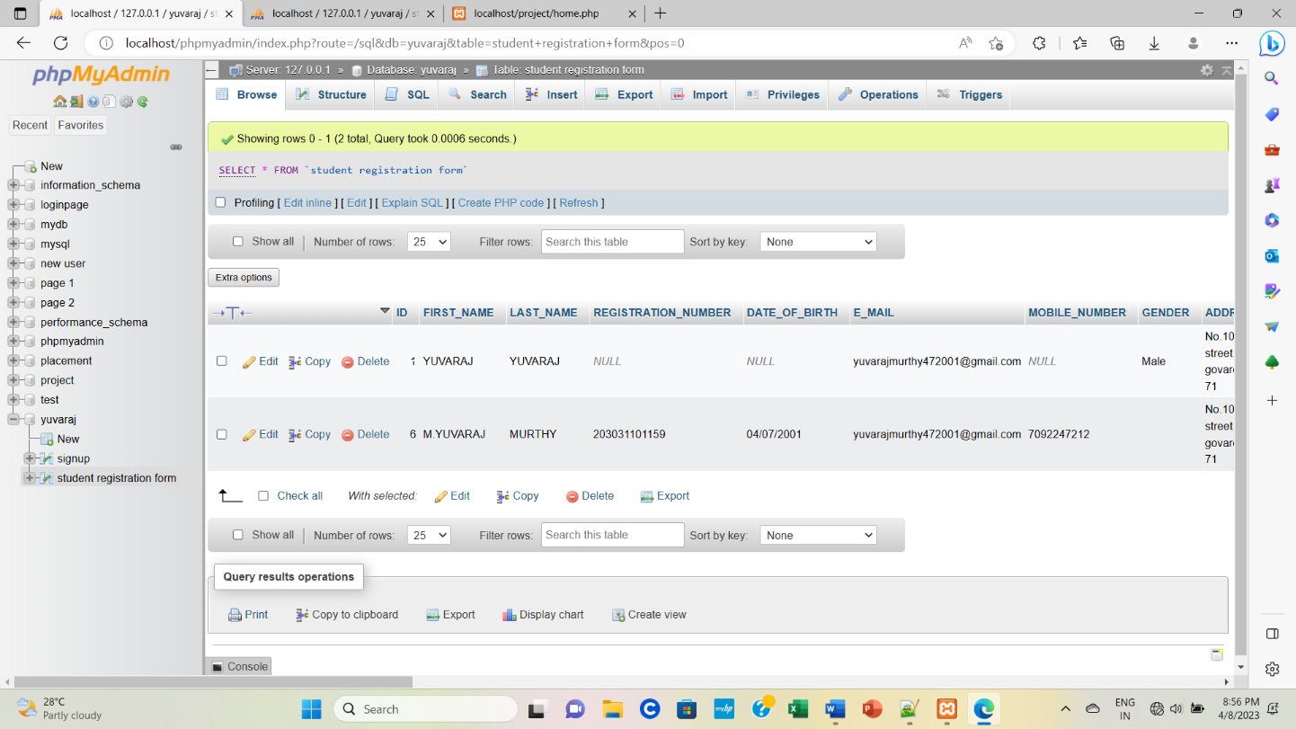

**CHAPTER 7**

**CONCLUSION**

**CONCLUSION**

Presently we designed our E-Placement management to be very User Friendly. Many features are enhanced to the present E- Placement management. With this E- Placement Cell most of the TPO’s time is saved. The features of the system can be further enhanced in many ways. The documentation that has enclosed can enable even a person with minimum knowledge to understand it well. E-placement management which is developed in HTML,CSS , PHP,MYSQL DATABASE , XAMPP control panel (local host) technology is a versatile product and is platform independent. The features provided by the E- Placement management makes it one of an interactive online platform for Placements.

**CHAPTER 8**

**REFERENCE**

1. “Modern PHP: New Features and Good Practices ”by Josh Lockhart(Latest edition 2nd Edition )
2. “PHP Objects, Pattern, and Practice” by Matt Zandstra (Latest edition : 5th Edition)
3. “MySQL (5TH Edition )” by Paul DuBois
4. “Effective MySQL Optimizing SQL statements(Oracle Press)” by Ronald Bradford
5. HTML and CSS Design and Build Websites by Jon Duckett (2nd Edition)
6. "HTML and CSS: Design and Build Websites" by Jon Duckett (2nd Edition, 2014)
7. "Learning Web Design: A Beginner's Guide to HTML, CSS, JavaScript, and Web Graphics"

by Jennifer Niederst Robbins (5th Edition, 2018)

1. "CSS: The Definitive Guide" by Eric Meyer (4th Edition, 2017)
2. "HTML5 and CSS3: Illustrated Complete" by Sasha Vodnik (2nd Edition, 2015)
3. "Head First HTML and CSS" by Elisabeth Robson and Eric Freeman (2nd Edition, 2012)
4. "PHP and MySQL Web Development" by Luke Welling and Laura Thomson. Edition: 5th, Year: 2016.
5. "PHP for the Web: Visual QuickStart Guide" by Larry Ullman. Edition: 5th, Year: 2016.
6. "Modern PHP: New Features and Good Practices" by Josh Lockhart. Edition: 1st, Year: 2015.
7. "PHP Cookbook: Solutions & Examples for PHP Programmers" by David Sklar and Adam Trachtenberg. Edition: 3rd, Year: 2014.
8. "PHP Objects, Patterns, and Practice" by Matt Zandstra. Edition: 4th, Year: 2013.
9. "Learning PHP, MySQL & JavaScript: With jQuery, CSS & HTML5" by Robin Nixon. Edition: 5th, Year: 2018.
10. "PHP Solutions: Dynamic Web Design Made Easy" by David Powers. Edition: 3rd, Year: 2014.
11. "Head First PHP & MySQL" by Lynn Beighley and Michael Morrison. Edition: 1st, Year: 2008.

**THANK YOU**